Software as a Service (SaaS)
# Source: AI Source: Provided by: [Data Path: Persons Table -> ID Column: 1, Name_En Column: Motasem Essam] -> From: [ChatGPT] on [1/26/2026]
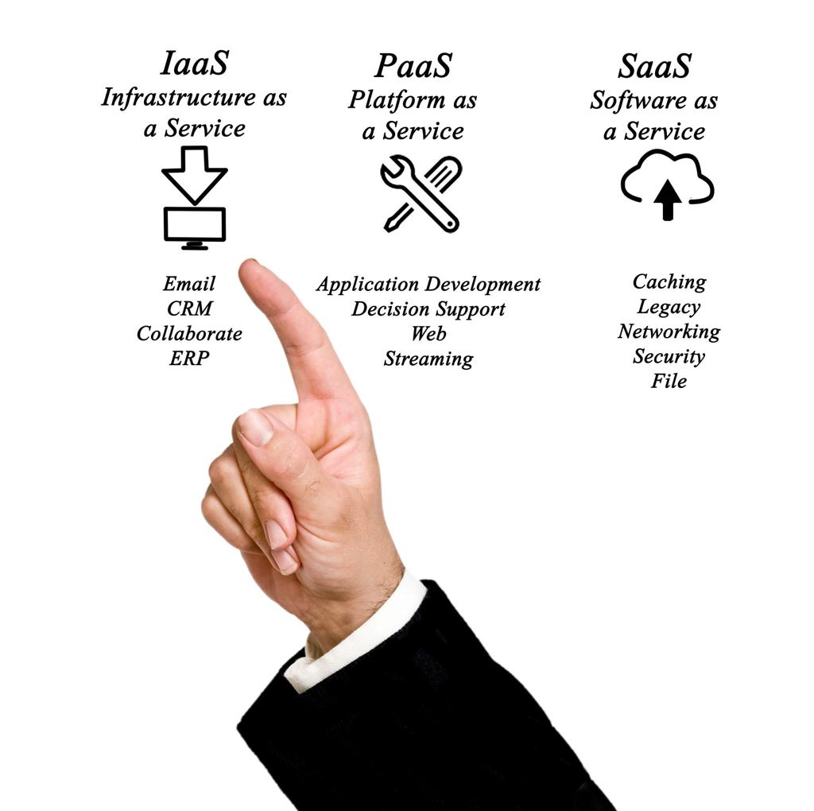
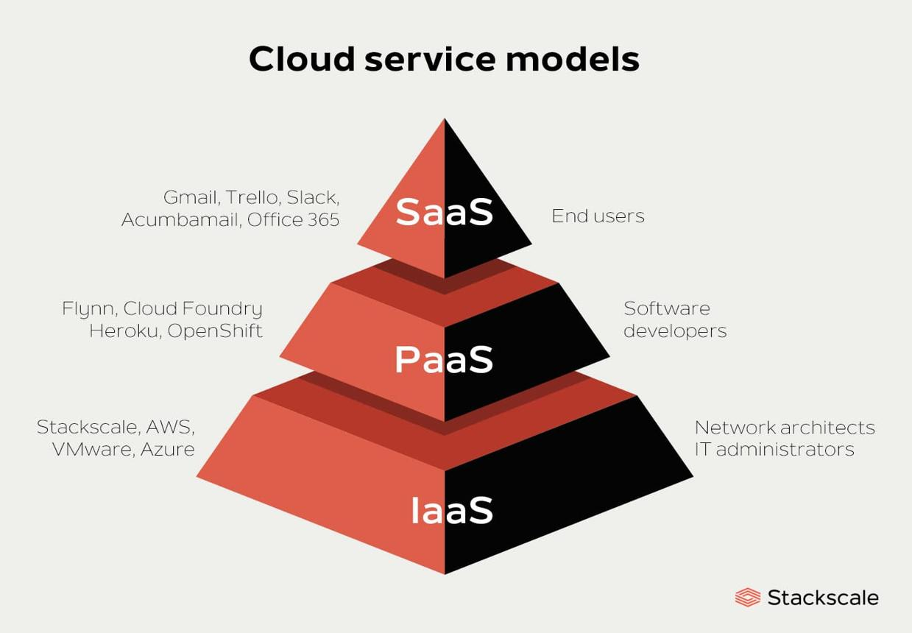
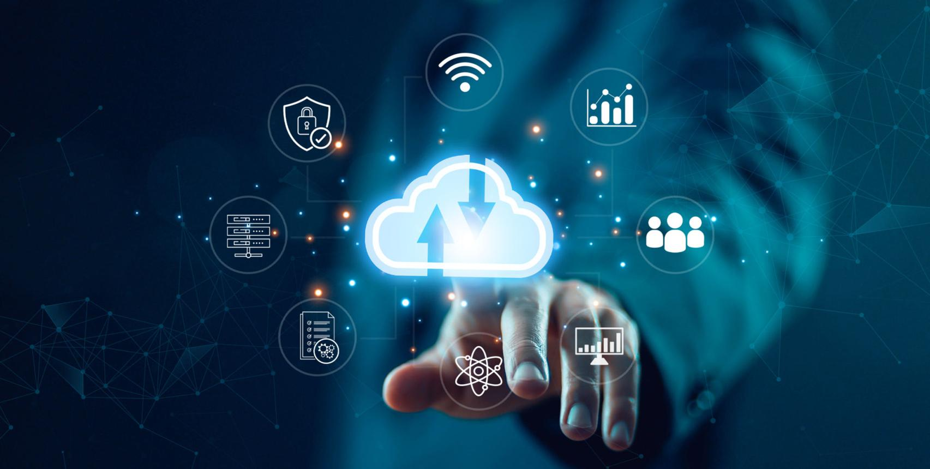
Software as a Service (SaaS) is a cloud computing model where you use fully functional applications over the internet without worrying about installation, maintenance, or infrastructure.

🧠 Simple Explanation
# Source: AI Source: Provided by: [Data Path: Persons Table -> ID Column: 1, Name_En Column: Motasem Essam] -> From: [ChatGPT] on [1/26/2026]
Think of SaaS like renting software online:
- You just use the application through a web browser
- The provider manages everything else: servers, updates, and security

⚙️ What You Get in SaaS
# Source: AI Source: Provided by: [Data Path: Persons Table -> ID Column: 1, Name_En Column: Motasem Essam] -> From: [ChatGPT] on [1/26/2026]
- 🖥️ Ready-to-use applications
- 🌐 Accessible from any device with internet
- 🔄 Automatic updates and maintenance
- 👥 Multi-user collaboration features
👉 You manage:
- Your account
- Personal settings and data

🏢 Popular SaaS Providers
# Source: AI Source: Provided by: [Data Path: Persons Table -> ID Column: 1, Name_En Column: Motasem Essam] -> From: [ChatGPT] on [1/26/2026]
- Google Workspace
- Microsoft 365
- Salesforce

🔑 Key Features
# Source: AI Source: Provided by: [Data Path: Persons Table -> ID Column: 1, Name_En Column: Motasem Essam] -> From: [ChatGPT] on [1/26/2026]
- No installation required
- Accessible anywhere
- Subscription-based payment
- Collaborative tools and real-time updates

📦 Example
# Source: AI Source: Provided by: [Data Path: Persons Table -> ID Column: 1, Name_En Column: Motasem Essam] -> From: [ChatGPT] on [1/26/2026]
- Using Gmail to send emails
- Using Google Docs to write documents collaboratively
- Using Salesforce to manage customer relationships

✅ Advantages
# Source: AI Source: Provided by: [Data Path: Persons Table -> ID Column: 1, Name_En Column: Motasem Essam] -> From: [ChatGPT] on [1/26/2026]
- Extremely easy to use
- No need to manage hardware or software
- Accessible from anywhere
- Updates and maintenance handled by provider

⚠️ Disadvantages
# Source: AI Source: Provided by: [Data Path: Persons Table -> ID Column: 1, Name_En Column: Motasem Essam] -> From: [ChatGPT] on [1/26/2026]
- Dependent on internet connection
- Less control over software features
- Potential data privacy concerns

📌 Summary
# Source: AI Source: Provided by: [Data Path: Persons Table -> ID Column: 1, Name_En Column: Motasem Essam] -> From: [ChatGPT] on [1/26/2026]
SaaS provides fully functional software over the internet, where the provider handles everything, and users only need to access and use the application.

